Ultrafast hydorgen migration in allene induced
by an intense femtosecond laser field
Tomoya Okino¹, Kaoru Yamanouchi¹ and Pham Hong Minh²
¹School of Science, The University of Tokyo, 7-3-1 Hongo, Bunkyo-ku, Tokyo, 113-0033, Japan.
²Institute of Physics, VAST, 10 DaoTan, BaDinh, Hanoi
E-mail: kaoru@.......
Abstract. Ultrafast hydrogen migration in allene (CH₂=C=CH₂) induced by intense laser fields was investigated by Coulomb explosion coincidence momentum imaging (CMI)...
Key word: Hydrogen migration, Allene, Intense laser field.
- INTRODUCTION
During the past few years, an ultrafast hydrogen migration process within a molecule in intense laser fields has been an attractive research theme, not only because of the findings that hydrogen atoms (or protons) move extremely rapidly within a molecule, but also their potential applicability for controlling chemical bond breaking processes [1, 2]…
- EXPERIMENTS
The schematic diagram of the experimental setup used in this experiment is shown in Fig. 1. The light source used in the experiments was a Ti:Sapphire femtosecond laser system (Pulsar 5000, Amplitude Technologies)…
- RESULTS AND DISCUSSION
Figure 1 shows the recorded time-of-flight (TOF) mass spectrum of the ionic species generated from C₃H₄ in the intense laser field…
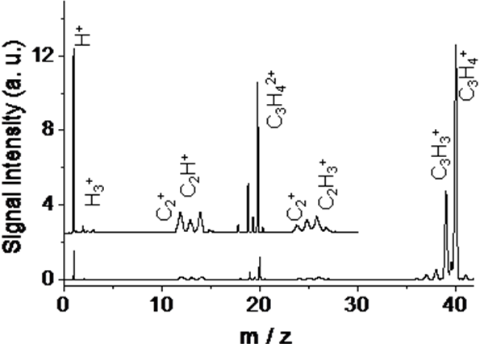
Signal Intensity (a.u.)
m /z

Fig.1. Time-of-flight mass spectrum of allene in an intense laser field (40 fs, 2×10¹³ W/cm²).

The momentum imaging maps of CH_{m}⁺ (m =1-3) appearing in coincidence with C₂H_{4-m}⁺ are shown in Figs. 3a-3c, which represent the two-body Coulomb explosion pathways Eq. (1).
$I(θ)=1+\sum_{L}{b_{L}\prod_{k=1}^{L/2}{\frac{{\left(1/{\text{τω}}\right)}^{2}+{\left(2k−1\right)}^{2}}{{\left(1/{\text{τω}}\right)}^{2}+{\left(2k\right)}^{2}}}P_{L}(\text{cos} θ_{m}^{0})P_{L}(\text{cos} θ)}$ (L= 2, 4, 6) (6)
where P_{L} denotes the Legendre polynomial and b_{L} reflects the angular distribution of the molecular principal axis of the parent molecules with respect to the laser polarization direction.
Table 1. The <cos² θ> values of the fragment ions, H_{n}⁺ and the parameters obtained by least-squares fits of Eq. (6).
Explosion pathways | θ_{m}⁰/deg | τω | τ /ps | <cos² θ>
C₃H₃⁺ + H⁺ (n = 1)  C₃H₂⁺ + H₂⁺ (n = 2)  C₃H⁺ + H₃⁺ (n = 3) | 29(2)  23(2)  12(4) | >5.0  >5.0  3.2 (1.1) | >1.9  >1.9  1.2(4) | 0.37  0.38  0.39
- CONCLUSION
The two-body and three-body Coulomb explosion of allene induced by an ultrafast intense laser field has been investigated by using the coincidence momentum imaging method…
- ACKNOWLEDGMENTS
The present research was supported by two grants from the Ministry of Education, Culture, Sports, Science and Technology (MEXT)…
REFERENCES
[1] A. Hishikawa, H. Hasegawa, and K. Yamanouchi, J. Electron Spectrosc. Relat. Phenom. Vol. 141, 2004, pp. 195-200.
[2] T. Kato, K. Yamanouchi, J. Chem. Phys. Vol. 131, 2009, pp.164118(1-14).
…

(Full papers should have a maximum page limit of 6 pages)

